**Index Portfolio of 3D Printing**

Lu Cao

**I Investment Thesis**

(1) Underlying: a class of equities that are exposed to 3D Printing services and technologies

(2) Weighting: use an optimal weighting schema to assign weights to each equity

(3) Rebalancing: implement daily rebalancing based on updated metric data

**II Content Universe**

(1) Companies exposed to 3D Printing from 3D Printing Business Directory

- <https://www.3dprintingbusiness.directory/companies/>

(2) List companies in the world from Yahoo Finance

- <https://finance.yahoo.com/quote>

(3) Stock prices and fundamental data from Bloomberg Terminal

(4) Google Search and Google Trends

**III Asset Selection Criteria**

(1) Listed companies & Exposed to 3D Printing services and technologies

Select listed companies that are exposed to 3D Printing services and technologies.

Information about all listed companies is from Yahoo Finance. Information about all companies exposed to 3D Printing services and technologies is from 3dprintingbusiness.com. Through string match, word match and google search verification, I successfully get company names and tickers of 87 listed companies from 3665 companies.

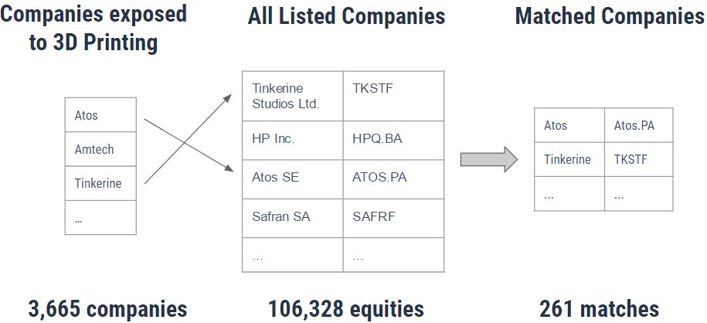

Figure 1: String Match Filter

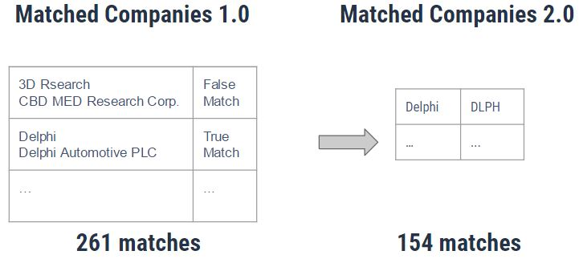

Figure 2: Word Match Filter

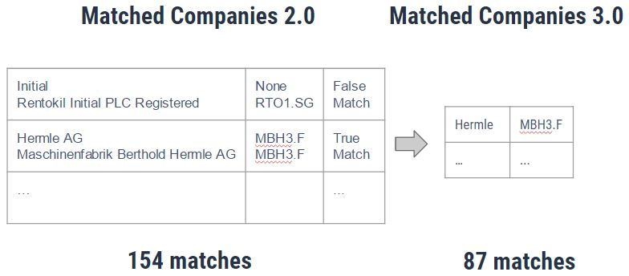

Figure 3: Google Search Match Verification

(2) Region

Select companies listed in United States to avoid the problem of different currency units and different market environments.

(3) Data Quality

Select companies with stocks whose data has smaller than 1% null and zero values. For data with small size missing data, we can use data imputing to clean data. However, for data with large size missing data, result based on it becomes much less reliable.

(4) Liquidity

Select companies with non-zero daily trading volume. Low-volume stocks are harder to buy or sell quickly and at the market price and they impose risks such as Challenges in fair price discovery, price manipulation possibility and etc.

(5) Volatility

Select companies with market cap above $50 million to avoid the risk and volatility brought by small companies since events such as take out often occur for small companies.

**IV Index Construction Methodology**

Each of the index portfolio below will select the 28 stocks above and weight those constituent stocks by the metric below. The traditional market cap index works as a baseline.

|  |  |
| --- | --- |
| Index Portfolio | Metric |
| Market-cap Weight Index | Market-cap |
| Price Weight Index | Close price |
| Equal Weight Index | Equal |
| Beta Weight Index | Beta |
| Revenue Weight Index | Trailing Revenue(3 months) |

**V Backtest**

The time frame of backtest is from 2011-01-01 to 2017-09-22. Based on google trends, the popularity of 3d printing experienced sharp increase starting from 2011.

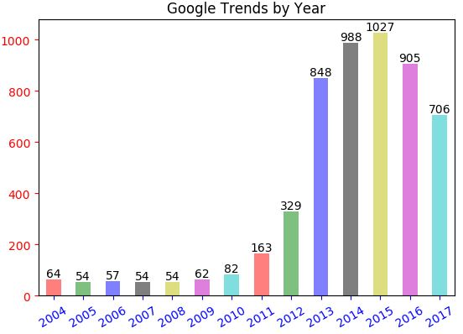

Figure 4 Google trends of “3d printing” by each year from 2004 to 2017

Below is a chart showing cumulative returns of each index type. The market-cap weight is at the top of the pack. It shows that alternative weights don’t give us superior returns.

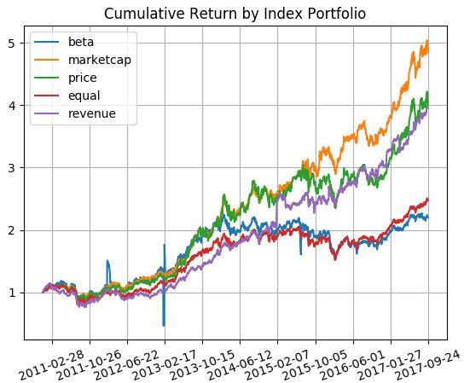

Figure 5 Cumulative return by index portfolio from 2010-01-01 to 2017-09-22

Below is a table showing the risk metrics of each index type. The market-cap weight gives the best cumulative return and Sharpe ratio and the smallest maximum drawdown and maximum daily loss.

|  |  |  |  |  |
| --- | --- | --- | --- | --- |
| Risk Metrics of Index Portfolio | | | | |
| Index Portfolio | Cumulative Return | Sharpe Ratio | Max Drawdown | Max Daily Loss |
| Market-cap | 4.84 | 1.18 | 23.56% | -6.66% |
| Revenue | 3.95 | 1.00 | 33.66% | -7.32% |
| Price | 4.00 | 0.85 | 24.86% | -6.59% |
| Equal | 2.47 | 0.58 | 30.32% | -7.47% |

Table 1 Risk metrics of index portfolio

**VI Conclusion**

Based on the backtest results, market-cap index portfolio has the best performance among other index alternatives from 2011-01-01 to 2017-09-22 with 484% cumulative return, 1.18 annualized Sharpe ratio, 23.56% max drawdown and -6.66% max daily loss.

In this project, the benefits of market-cap weighted strategy such as passive management liquidity and broad market participation overcomes its drawbacks such as overweighting overvalued equities. Other index alternatives don’t provide a more effective barometer with which to gauge value than market cap.

**VI Reference**

[1] Smart Beta Index Analysis in Python. (2016, June 10). Retrieved from <https://practicalquant.com/2016/06/10/whats-the-deal-with-smart-beta-indices/>